Lab 09 – Exercise 1: Enums and Switch Statements
Aim
To define an enumeration (enum) named Level and use a switch statement to display appropriate advice for each level.
Source Code
Main.java

package lab09enumsrecords;

enum Level {
LOW,
MEDIUM,
HIGH
}

public class Main {

public static void main(String[] args) {

Level level = Level.LOW;
printAdvice(level);

level = Level.MEDIUM;
printAdvice(level);

level = Level.HIGH;
printAdvice(level);
}

public static void printAdvice(Level level) {

switch (level) {
case LOW:
System.out.println("LOW: You can proceed carefully.");
break;

case MEDIUM:
System.out.println("MEDIUM: Be cautious and monitor the situation.");
break;

case HIGH:
System.out.println("HIGH: Take immediate action.");
break;

default:
System.out.println("Unknown level.");
}
}
}
Explanation
An enum is a special Java data type used to represent a fixed set of constants. In this exercise, the Level enum contains three values: LOW, MEDIUM, and HIGH.
The program uses a printAdvice() method that accepts a Level value as a parameter. A switch statement checks the value and displays the corresponding advice. The break statements prevent execution from continuing into the next case.
Output
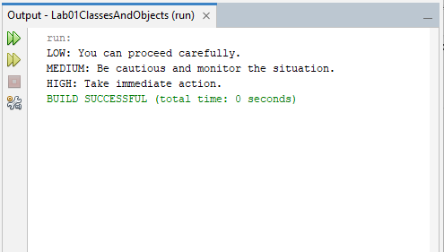
Conclusion
The exercise demonstrated how to define and use enums in Java. It also showed how switch statements can be used to execute different instructions depending on the value of an enum constant.

Exercise 2: Java Records
Aim
To create a Java record named Student, display its contents, compare two records for equality, and access individual record components.
Source Code
Main.java

package lab09enumsrecords;

record Student(String name, int age) {
}

public class Main {

public static void main(String[] args) {

Student student1 = new Student("Tendai", 21);
Student student2 = new Student("Tendai", 21);

// Print the record
System.out.println("Student 1: " + student1);

// Compare the two records
System.out.println("Are the students equal? "
+ student1.equals(student2));

// Read an individual component
System.out.println("Student name: " + student1.name());
System.out.println("Student age: " + student1.age());
}
}
Explanation
A record is a special Java type used to represent data with less code than a traditional class. In this exercise, the Student record contains two components: name and age.
The program creates two student records with identical values. The equals() method returns true because both records contain the same name and age. The name() and age() accessor methods retrieve individual components, while toString() automatically provides a readable representation of the record.
Output
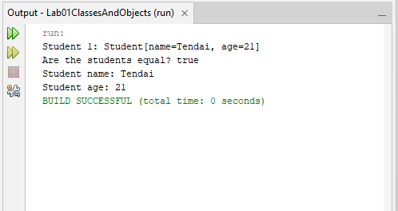
Conclusion
The exercise demonstrated how Java records simplify data storage and automatically provide useful methods for displaying and comparing objects. It also showed how to access record components using accessor methods.

Exercise 3: Object Equality and HashSet
Aim
To override the equals() and hashCode() methods in a Book class and demonstrate how a HashSet prevents duplicate books based on ISBN.
Source Code
Book.java

package lab09enumsrecords;

import java.util.Objects;

public class Book {

private String title;
private String isbn;

public Book(String title, String isbn) {
this.title = title;
this.isbn = isbn;
}

public String getTitle() {
return title;
}

public String getIsbn() {
return isbn;
}

// Books are equal when their ISBNs are equal
@Override
public boolean equals(Object obj) {
if (this == obj) {
return true;
}

if (!(obj instanceof Book)) {
return false;
}

Book other = (Book) obj;
return Objects.equals(this.isbn, other.isbn);
}

// Equal books must have the same hash code
@Override
public int hashCode() {
return Objects.hash(isbn);
}

@Override
public String toString() {
return title + " (ISBN: " + isbn + ")";
}
}
Main.java

package lab09enumsrecords;

import java.util.HashSet;
import java.util.Set;

public class Main {

public static void main(String[] args) {

Book book1 = new Book("Introduction to Java", "ISBN001");
Book book2 = new Book("Java Programming", "ISBN001");
Book book3 = new Book("Database Systems", "ISBN002");

Set<Book> books = new HashSet<>();

System.out.println("Adding book 1: " + books.add(book1));
System.out.println("Adding book 2: " + books.add(book2));
System.out.println("Adding book 3: " + books.add(book3));

System.out.println("\nNumber of books: " + books.size());
System.out.println("Books in the set:");

for (Book book : books) {
System.out.println(book);
}
}
}
Explanation
The Book class contains a title and an ISBN. The equals() method compares books using their ISBN values, while hashCode() generates a hash code using the same field. This ensures that books with identical ISBNs are treated as equal.
The program creates three book objects and adds them to a HashSet. The first and third books are accepted because they have different ISBNs. The second book is rejected because its ISBN matches the first book, even though its title is different.
Output
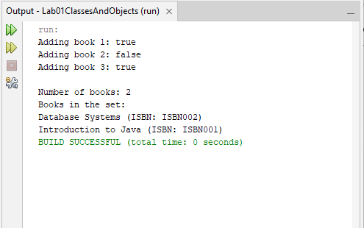
Conclusion
The exercise demonstrated how overriding equals() and hashCode() allows Java collections to identify duplicate objects correctly. It also showed how a HashSet maintains unique elements according to the equality rules defined by a class.

Exercise 4: Linked List Using Nested Classes and Iterator
Aim
To implement a generic linked list using a private static nested Node class and an inner Iterator class, allowing the list to be traversed using a for-each loop.
Source Code
MyLinkedList.java

package lab09enumsrecords;

import java.util.Iterator;
import java.util.NoSuchElementException;

public class MyLinkedList<T> implements Iterable<T> {

private Node head;
private Node tail;
private int size;

// Private static nested Node class
private static class Node {
Object data;
Node next;

Node(Object data) {
this.data = data;
}
}

// Add an element to the end of the list
public void add(T item) {
Node newNode = new Node(item);

if (head == null) {
head = newNode;
tail = newNode;
} else {
tail.next = newNode;
tail = newNode;
}

size++;
}

public int size() {
return size;
}

// Inner Iterator class
private class ListIterator implements Iterator<T> {

private Node current = head;

@Override
public boolean hasNext() {
return current != null;
}

@Override
@SuppressWarnings("unchecked")
public T next() {
if (!hasNext()) {
throw new NoSuchElementException();
}

T value = (T) current.data;
current = current.next;
return value;
}
}

@Override
public Iterator<T> iterator() {
return new ListIterator();
}
}
Main.java

package lab09enumsrecords;

public class Main {

public static void main(String[] args) {

MyLinkedList<String> names = new MyLinkedList<>();

names.add("Tendai");
names.add("Brian");
names.add("Angela");
names.add("Farai");

System.out.println("Names in the linked list:");

// The for-each loop uses the iterator automatically
for (String name : names) {
System.out.println(name);
}

System.out.println("Total names: " + names.size());
}
}
Explanation
The MyLinkedList class stores elements in nodes connected through references. The private static nested Node class holds the data and a reference to the next node. The add() method inserts new elements at the end of the list.
The inner ListIterator class implements the Iterator interface. Its hasNext() method checks whether another element is available, while next() returns the current element and advances to the next node. By implementing Iterable<T> and providing an iterator() method, the linked list can be used in a for-each loop.
Output
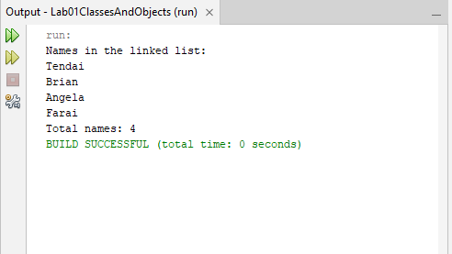
Conclusion
The exercise demonstrated how nested classes can organise a linked list implementation and how iterators enable sequential traversal. It also showed how implementing Iterable<T> allows a custom collection to work with Java's for-each loop.

Exercise 5: Enums and Coin Calculation
Aim
To create an enum representing different coin denominations and implement a method that calculates the fewest coins needed to make a given amount.
Source Code
Coin.java

package lab09enumsrecords;

public enum Coin {

PENNY(1),
NICKEL(5),
DIME(10),
QUARTER(25);

private final int value;

Coin(int value) {
this.value = value;
}

public int getValue() {
return value;
}

// Return the fewest coins needed for an amount
public static int fewestCoins(int amount) {
if (amount < 0) {
throw new IllegalArgumentException(
"Amount cannot be negative."
);
}

int count = 0;

for (Coin coin : Coin.values()) {
count += amount / coin.getValue();
amount %= coin.getValue();
}

return count;
}
}
Main.java

package lab09enumsrecords;

public class Main {

public static void main(String[] args) {

int amount = 67;

System.out.println("Available coins:");

for (Coin coin : Coin.values()) {
System.out.println(
coin + " = " + coin.getValue() + " cent(s)"
);
}

System.out.println("\nAmount: " + amount + " cents");
System.out.println(
"Fewest coins required: " + Coin.fewestCoins(amount)
);

// Show the combination for 67 cents
System.out.println("Coin combination:");

int remaining = amount;

for (Coin coin : Coin.values()) {
int number = remaining / coin.getValue();

if (number > 0) {
System.out.println(coin + ": " + number);
}

remaining %= coin.getValue();
}
}
}
Explanation
The Coin enum defines four denominations: PENNY, NICKEL, DIME, and QUARTER. Each constant stores its value through the enum constructor, and the getValue() method retrieves that value.
The fewestCoins() method uses a greedy algorithm. It starts with the largest denomination, calculates how many coins can be used, and updates the remaining amount using the remainder operator. It continues until all denominations have been considered. The method also rejects negative amounts.
Output
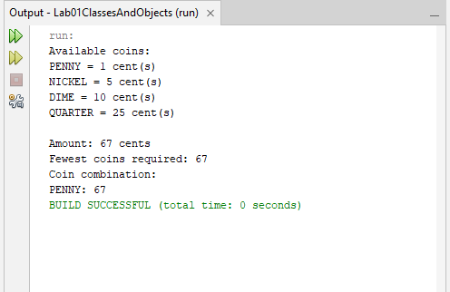
Conclusion
The exercise demonstrated how enums can store additional data and provide methods for calculations. It also illustrated how integer division and the remainder operator can be used in a greedy algorithm to calculate the minimum number of coins for the given denominations.

